Chapter 8: Review Exercise Solutions

R8.1

VendingMachine would be an appropriate name for the class because it a) simulates a vending machine, and b) has functionality that matches vending machine functionality exactly, without more or less functions.

PriceChecker would not be an appropriate name for the class because while it does check the price, it also performs a transaction.

ChangeGiver would not be an appropriate name for the class because while it does give change when too much money is given, it will return the money paid if there is not enough.

R8.2

a) Invoice would be a good class to use if the goal was to keep track of the invoice as a digital record. The application only takes the information in to print the invoice, so this could be misleading.

b) InvoicePrinter is a good class to use for this application, because it describes exactly the functionality of the application.

c) PrintInvoice works as a description of the application, but might not be the best choice because it sounds more like a function or an action than an entire class.

d) InvoiceProgram would be a good class to use if there were more than one action the application could perform. Using the word “program” implies that there are multiple possible functions of the application, whereas one could more easily use the single action provided by the application in its name.

R8.3

Actor Class – PaycheckComputer

Non-Actor Class – Payroll

The difference between the two classes if the implied functionality. The actor class defines its functional capacity of the class within its name, whereas the non-actor class only provides the general description of the functionality.

R8.4

The System class is not cohesive because it includes many features that are unrelated, such as console I/O, garbage collection, and the time in milliseconds.

R8.5

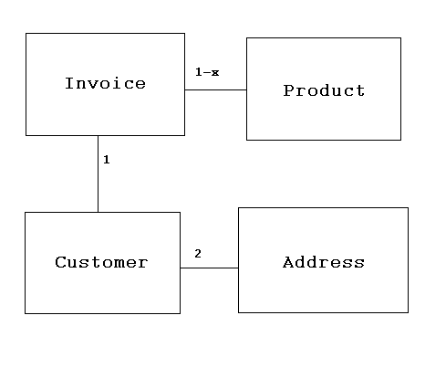

R8.6

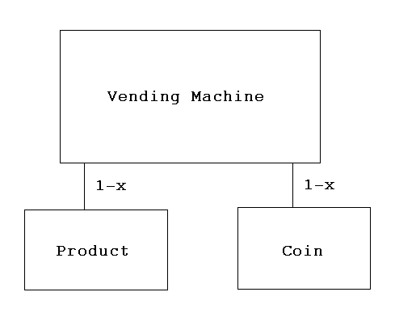

R8.7

The Integer class depends on the String class.

R8.8

The class Rectangle depends on the Rectangle2D, Point, Dimension, and String classes.

R8.9

boolean hasNext() – Accessor
boolean hasNextDouble() – Accessor
boolean hasNextInt() – Accessor
boolean hasNextLine() – Accessor
String next() – Mutator
double nextDouble() – Mutator
int nextInt() – Mutator
String nextLine() – Mutator

R8.10

Accessor methods:

contains
createIntersection
createUnion
equals
getBounds
getBounds2D
getHeight
getLocation
getSize
getWidth
getX
getY
intersection
intersects
isEmpty
outcode
toString
union

Mutator methods:

add
grow
setBounds
setLocation
setRect
setSize
translate

R8.11

The Resistor class in problem P8.8 is immutable because all of its functions are accessors.

R8.12

Of the three class, Rectangle, String, and Random, only class String is immutable.

R8.13

Of the three classes PrintStream, Date, and Integer, the Integer class is immutable.

R8.14

The side effect of the read() method is that it modifies the Scanner parameter that is passed in. A redesign would be to use the Scanner object within a main() method that passes in strings one at a time to the DataSet object.

R8.15

public void print() The side effect is modifying System.out to print on the console.
public void print(PrintStream stream) The side effect is modifying the stream parameter.
public String toString() There is no side effect.

R8.16

If no function (including main) has a side effect, then you could not observe the program doing anything. Such a program would be useless. (Note that producing output on the screen is a side effect.)

R8.17

When you call falseSwap, then a is initialized with 3 and b is initialized with 4. At the end of the falseSwap method, a is 4 and b is 3. Then the method exits and its local variables (including the parameter variables) are forgotten. The contents of x and y are not affected.

R8.18

public static void swap(Point2D.Double p)
{
p.setLocation(p.getY(), p.getX());
}

public static void main(String[] args)
{
double x = 3;
double y = 4;
Point2D.Double p = new Point2D.Double(x, y);
swap(p);
x = p.getX();
y = p.getY();
System.out.println(x + " " + y);
}

R8.19

TODO

R8.20

TODO

R8.21

We get the error message "non-static method print(int) cannot be referenced from a static context" because the print method is not declared as static. If you change the header of the method to public static void print(int x), then the program will work. The reason the method needs to be declared as static is because we are calling it without an object reference (implicit parameter), but only static methods can be called like that.

R8.22

decode
getInteger
highestOneBit
lowestOneBit
numberOfLeadingZeros
numberOfTrailingZeros
parseInt
reverse
reverseBytes
rotateLeft
rotateRight
signum
toBinaryString
toHexString
toOctalString
toString // all of the toString variations, except toString()
valueOf

They are static methods because these methods do not need an implicit parameter.

R8.23

All of the valueOf methods in the String class are static methods. Like the methods in the Integer class, these methods are static because these methods do not operate on an object and have only explicit parameters. They create a new String instead of modifying an existing String (implicit parameter, which these methods do not need). The format methods are also static, for the same reason.

R8.24

It is not a good design because using public static variables is not a good idea; they can accidentally get overwritten in large programs. A better way to do this is to have static methods System.getIn() and System.getOut() that return these streams.

R8.25

To write a Java program without import statements, the user needs to specify the path names of the classes that are used in the program.

/**
A component that draws two rectangles.
*/
public class RectangleComponent extends javax.swing.JComponent
{
public void paintComponent(java.awt.Graphics g)
{
// Recover Graphics2D
java.awt.Graphics2D g2 = (java.awt.Graphics2D) g;

// Construct a rectangle and draw it
java.awt.Rectangle box = new java.awt.Rectangle(5, 10, 20, 30);
g2.draw(box);

// Move rectangle 15 units to the right and 25 units down
box.translate(15, 25);

// Draw moved rectangle
g2.draw(box);
}
}

R8.26

The default package is the package that contains the classes with no package specifier. All classes that we have programmed up to this point were in the default package.

R8.27

The exception is reported, and the remaining methods continue to be executed. This is an advantage over a simple tester class whose main method would terminate when an exception occurs, skipping all remaining tests.

